Name: ______________
Date:______________

Elephant Genetics: Do Your Ears Hang Low?
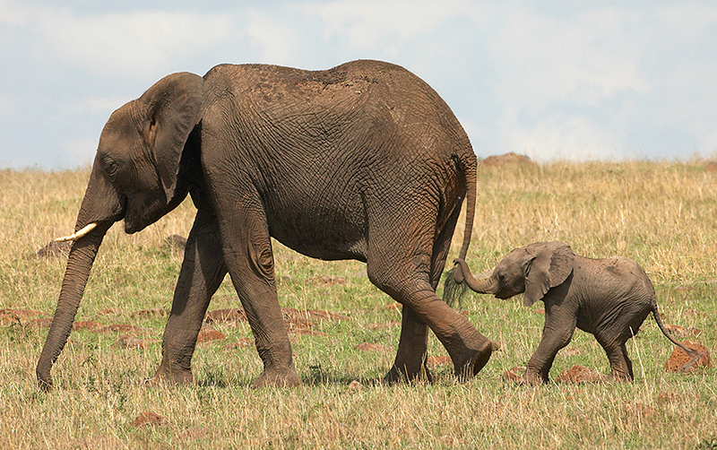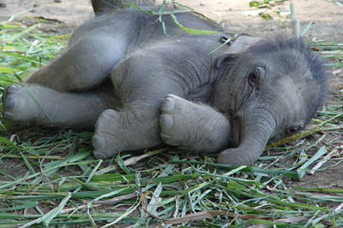

Directions: You and your partner are going to be the proud parents of 20 baby elephants! Some of your baby elephants will have big ears, and some will have small ears. For this activity, we will say that this trait is determined by a single gene. There are two forms of this gene: H and T. Remember: a gene is a specific section of a chromosome, and babies receive two copies of each chromosome—one from each parent.

To determine whether each elephant will have big ears or small ears, you will each flip a coin. Once you have flipped your coins, you will use the following rules to decide the size of your elephant’s ears.

Coin Flip | Ear Size
2 Heads (HH) | Big
1 Head, 1 Tail (HT) | Big
2 Tails (TT) | Small

You will repeat this process 19 more times for a total of 20 baby elephants. Record your results in the table below.

Elephant | Partner #1 Flip | Partner #2 Flip | Ear Size
1
2
3
4
5
6
7
8
9
10
11
12
13
14
15
16
17
18
19
20

Total Number of Big-Eared Elephants: _______

Total Number of Small-Eared Elephants:_______

